KL Wolley
10/29/2018
Induction Homework
Part A

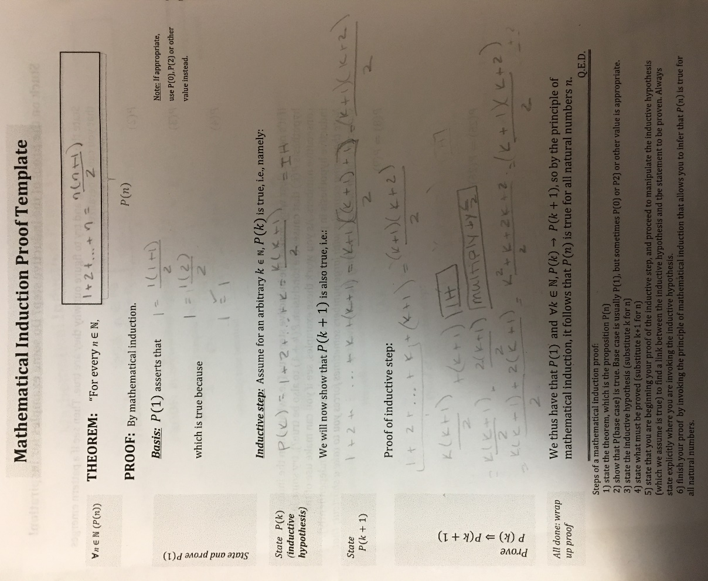
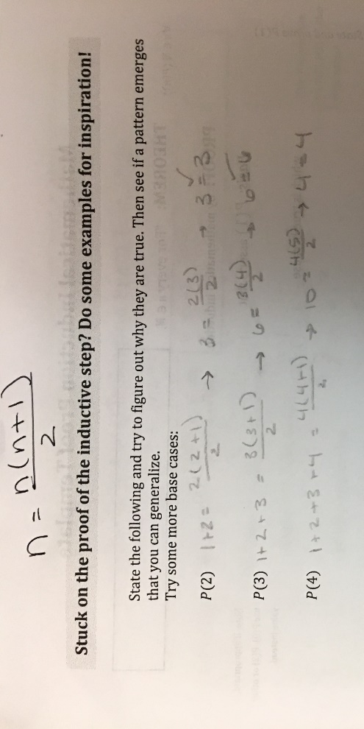
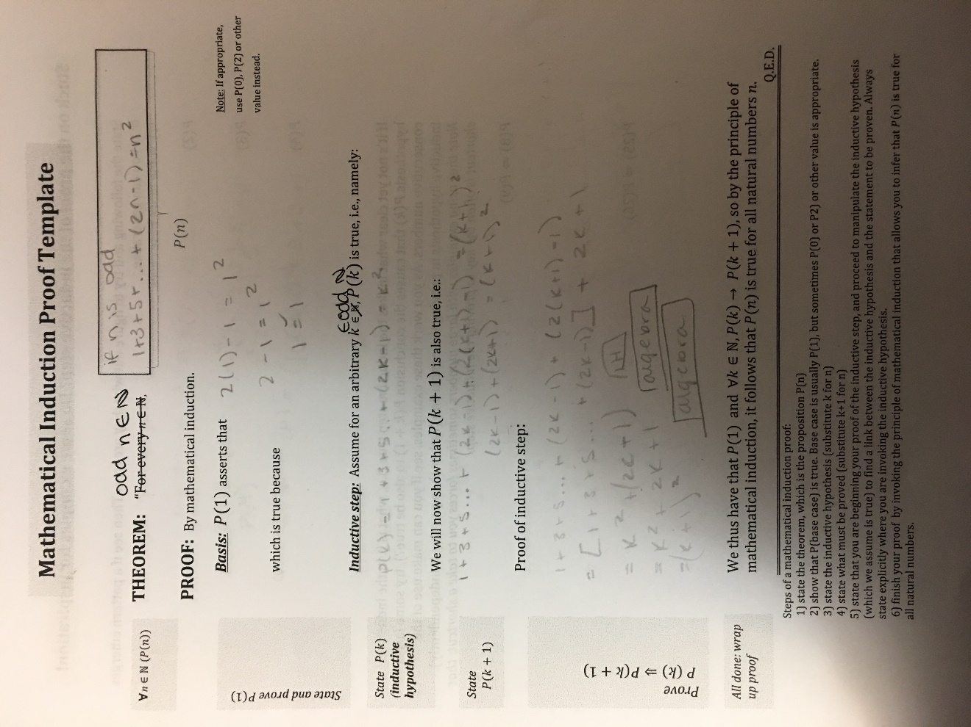
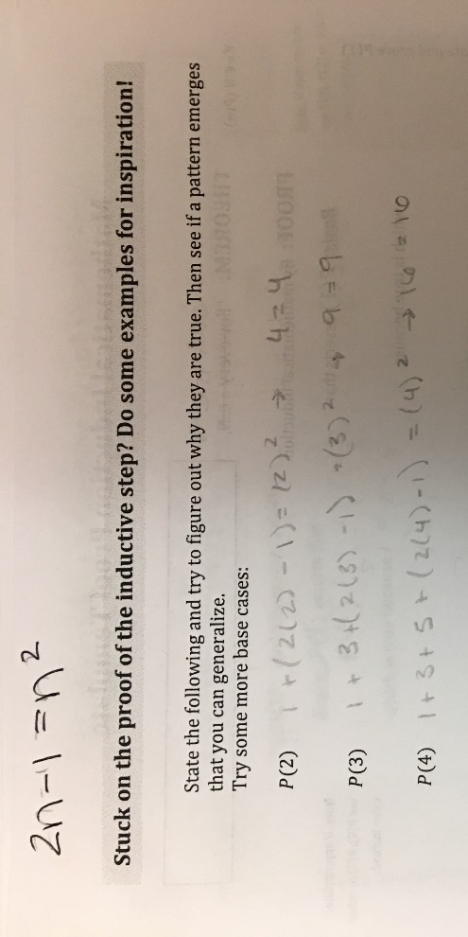

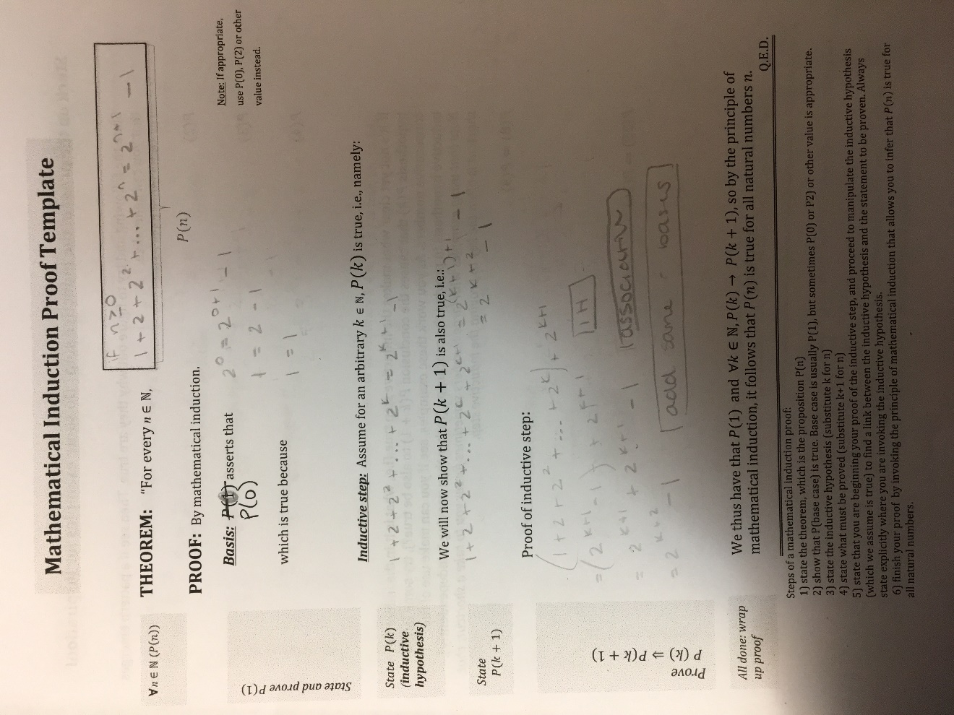
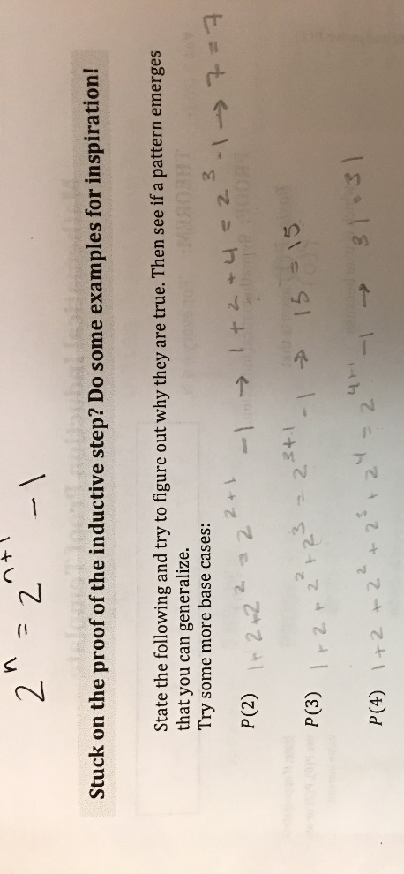

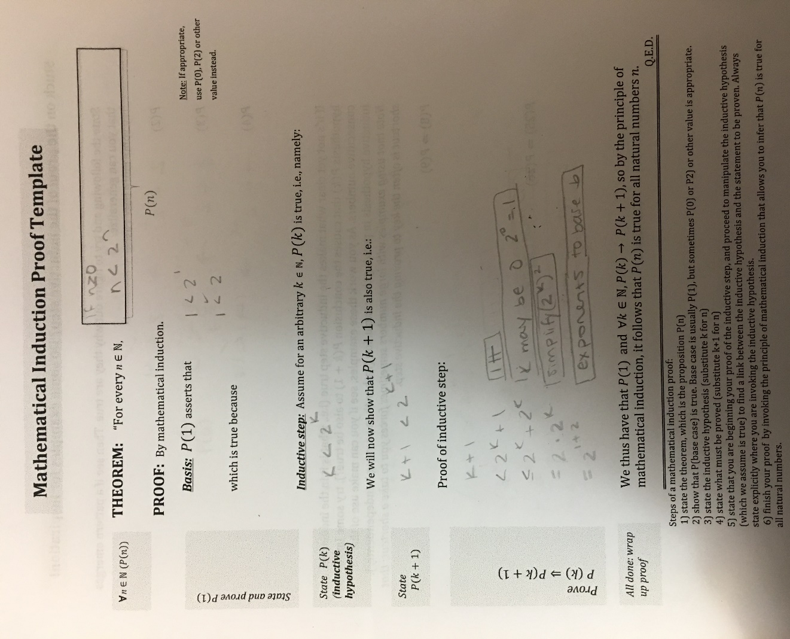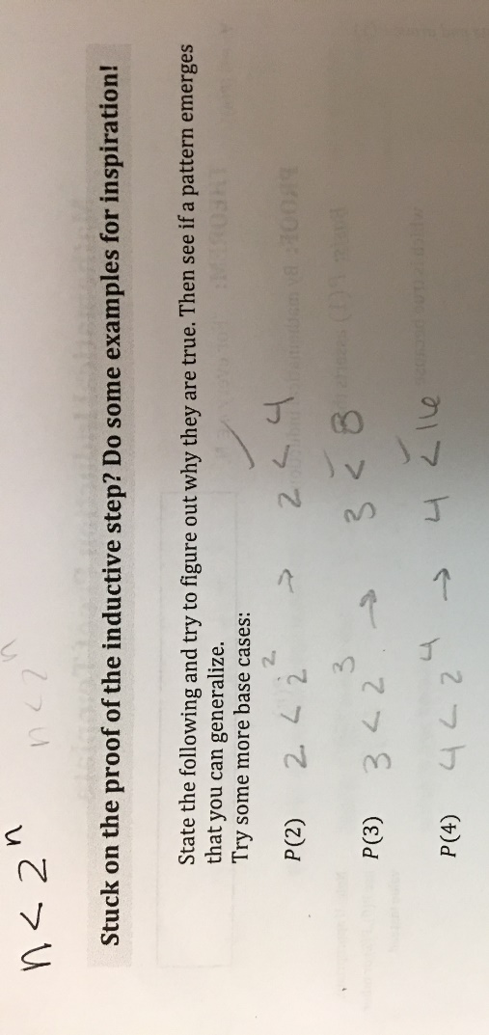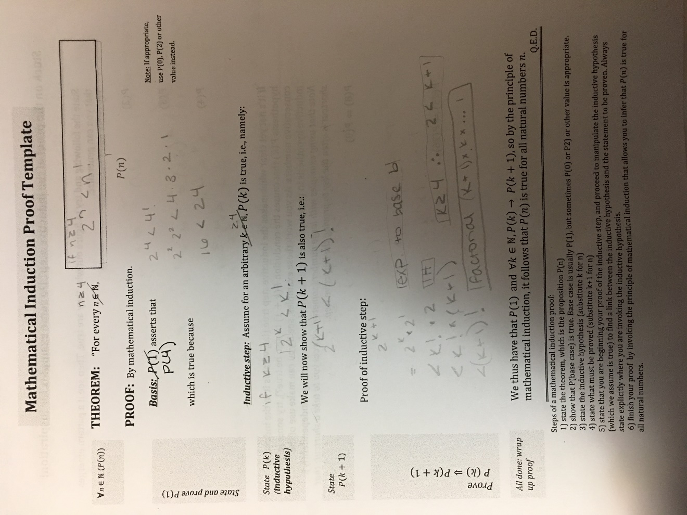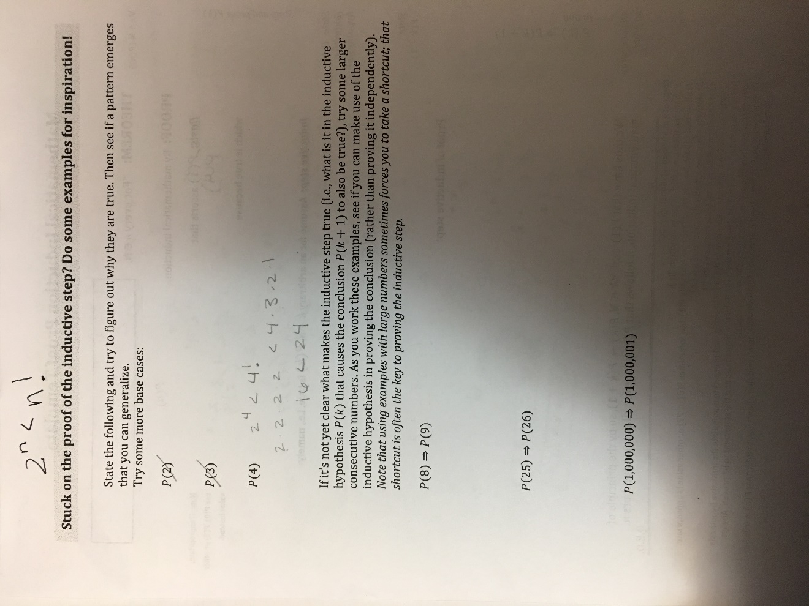

Part B
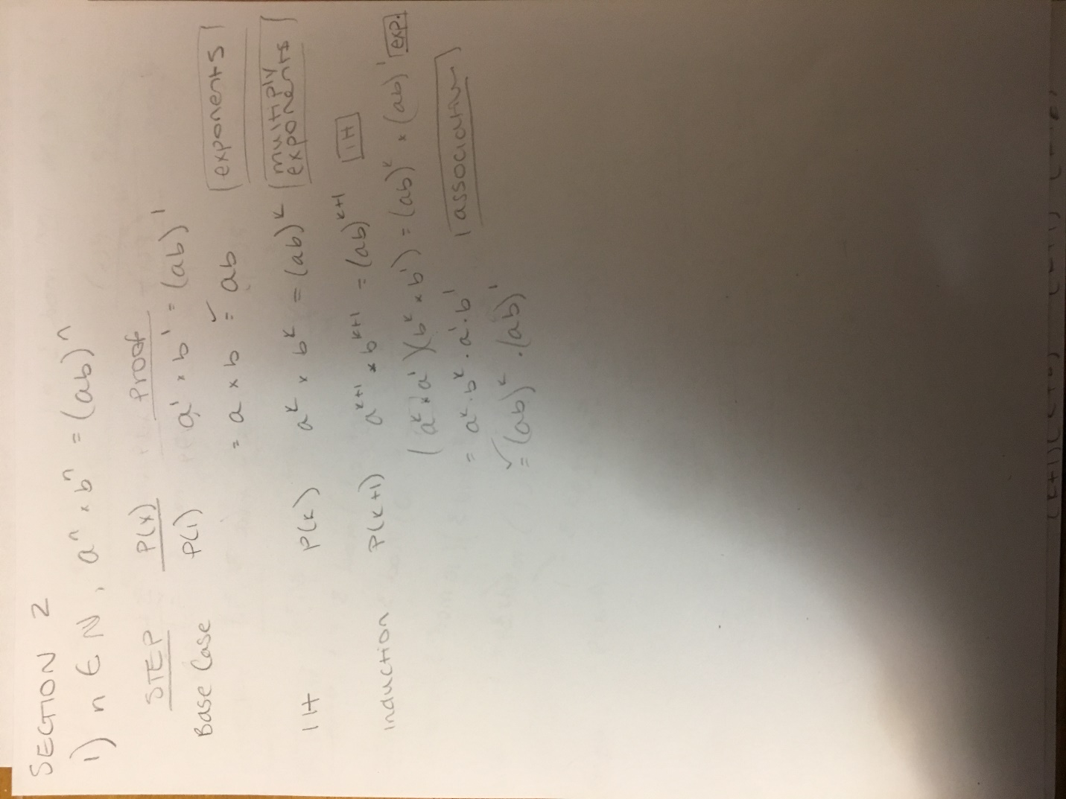
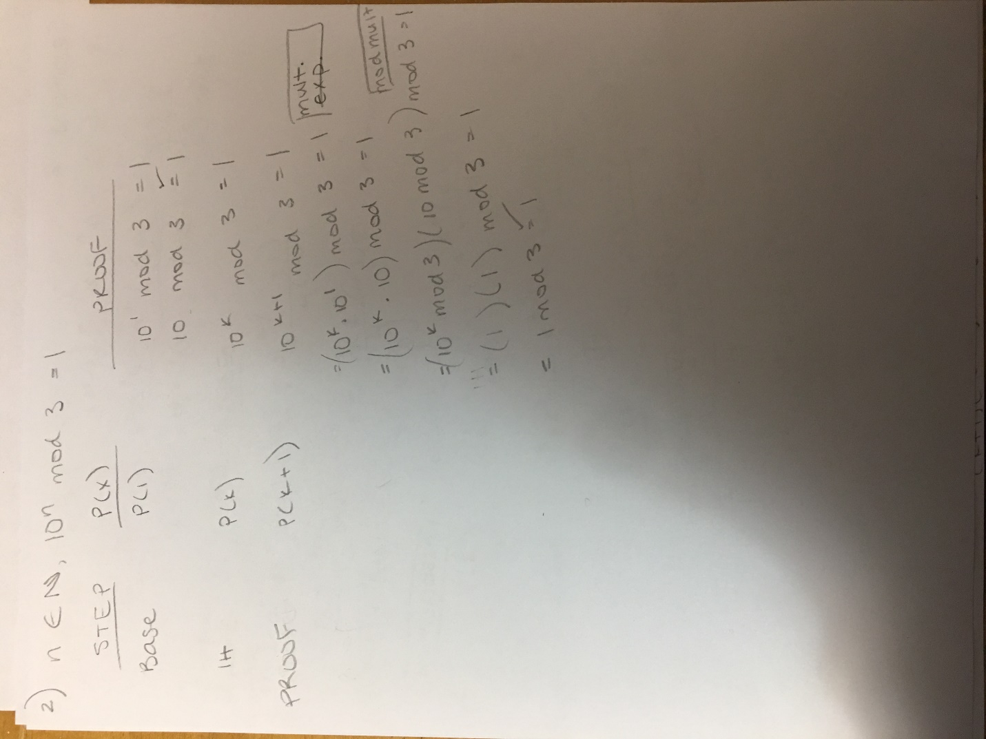
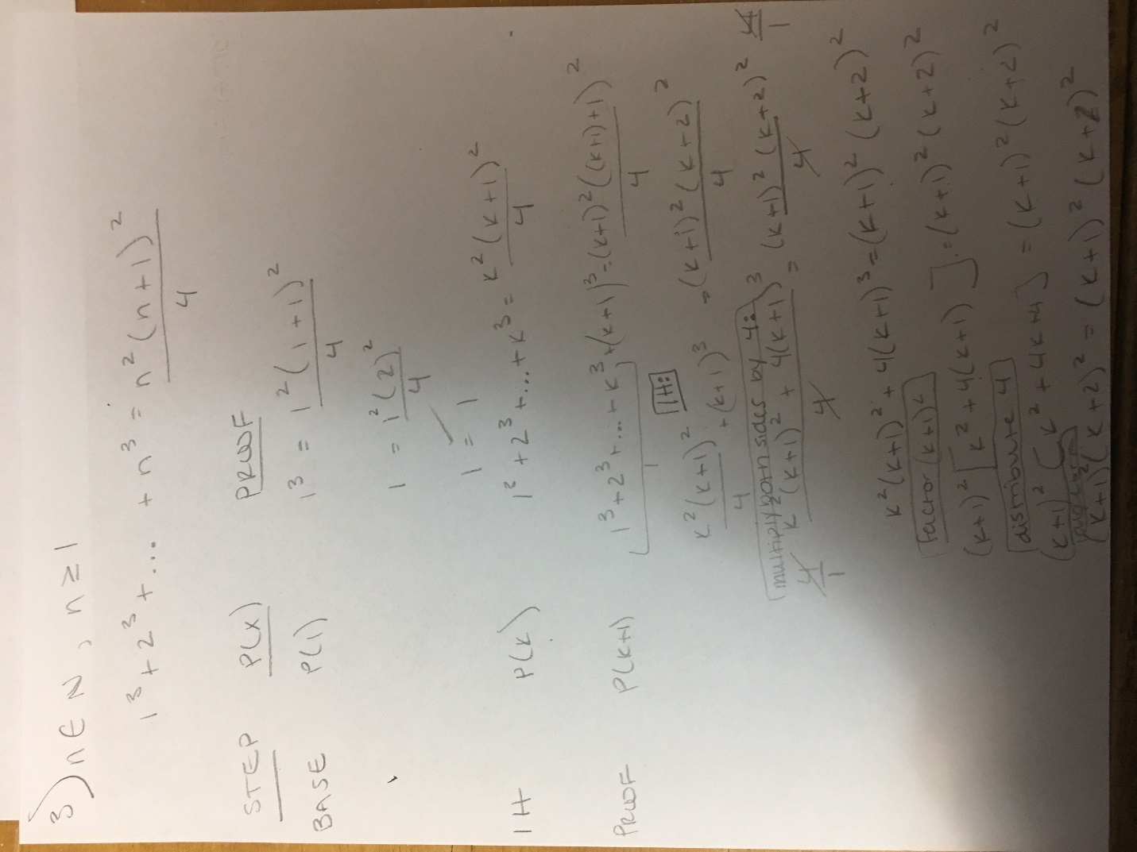

Part C
The block video of the sum of values n can be a great visual aid to the induction proof. As in the video, the first part of the proof is to assess the theorem at a n= 1 (see below).
1+2+…+n = n(n+1)/2
For the base case of n = 1 you would get the following:
1 = 1(1+2)/2
1 = 1
Similarly, for the block video, an n of 1 would include only 1 block. Therefore, the sum of the blocks in the “half the square” is 1.
If we assume that for any given value of k the theorem is true, using the block video, you can see that for any number of blocks in a column, the theorem would continue to hold true for the column directly to the right, that is, a column with size k + 1 blocks. The “staircase” could be added to indefinitely and the calculation of “half the square” would continue to equal the number of blocks used.

